# Account Management

## Register New Account

On the Home page, click on the “Members” link in the nav bar.

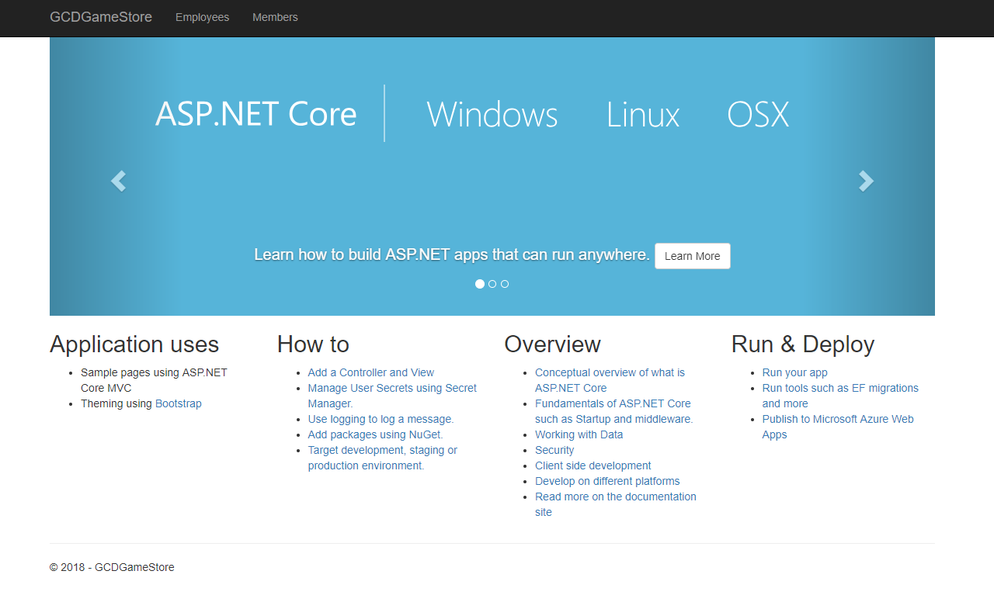

This will bring up the log in page. Click the “Register New Account” button.

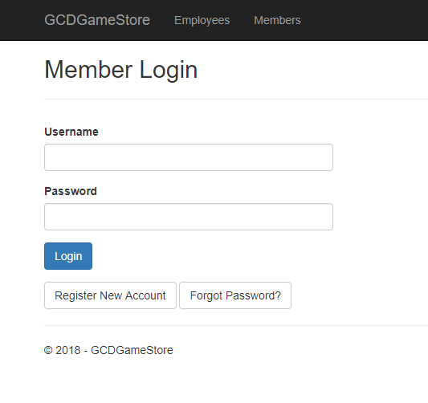

This will bring up a form to enter the necessary information to create a new account.

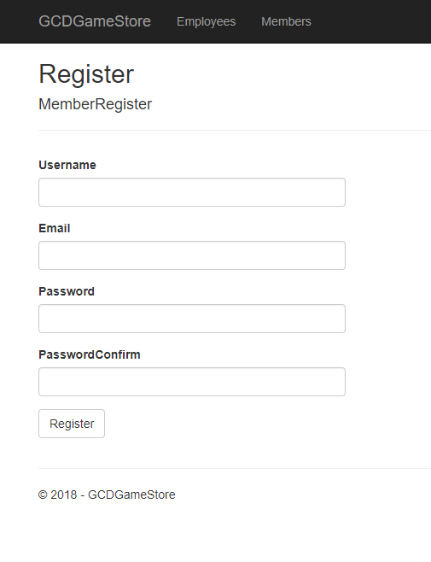

Enter the account information and click on the “Register” button.

## Logging In

On the Home page, click on the “Members” link in the navigation bar.



This will bring up the login page. Enter your information and click on the “Login” button.



## Change Password

After logging in the profile page is displayed. Select the “Change password” link located at the bottom.

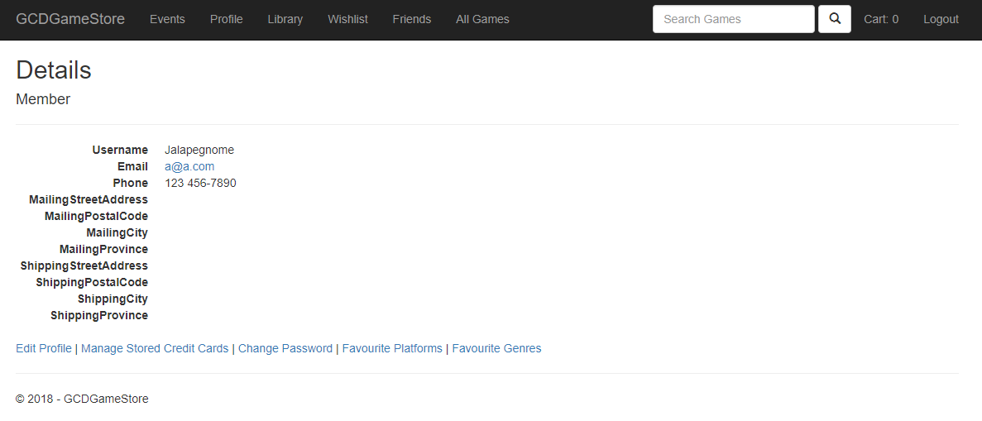

## Logout

In the upper left of the navigation bar, select the “Logout” link